CompSim

Ryan Bleile

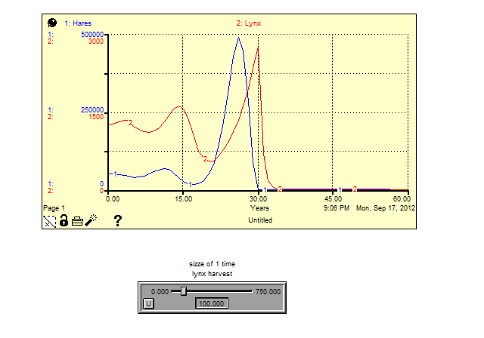The lynx harvest has a great effect on the eventual long term behavior of the system. We were able to demonstrate the differences that the harvest makes by figuring out the limit between harvesting the population drives the populations out of control and what harvest size will kill the populations off entirely in the long run. These values are 48/49. At 48 the lynx and hare populations will eventually spiral out of control. At 49 they will eventually die off entirely. The time period after the harvest has expected oscillatory behavior with the lynx population trailing behind the hare population’s changes. With these set parameters though the populations tend to change rapidly and this is in part I believe what causes the two edge cases for out of control growth and population death. If we change the harvest to be an extreme harvest we will drive the populations to die off faster. If we do not harvest any lynx than we drive the populations out of control quickly.

